EXP1:Generation and Classification of Continuous-Time and Discrete-Time Signals
(i)To generate and visualize basic continuous-time signals such as unit step, unit impulse, ramp, sinusoidal, and exponential signals.
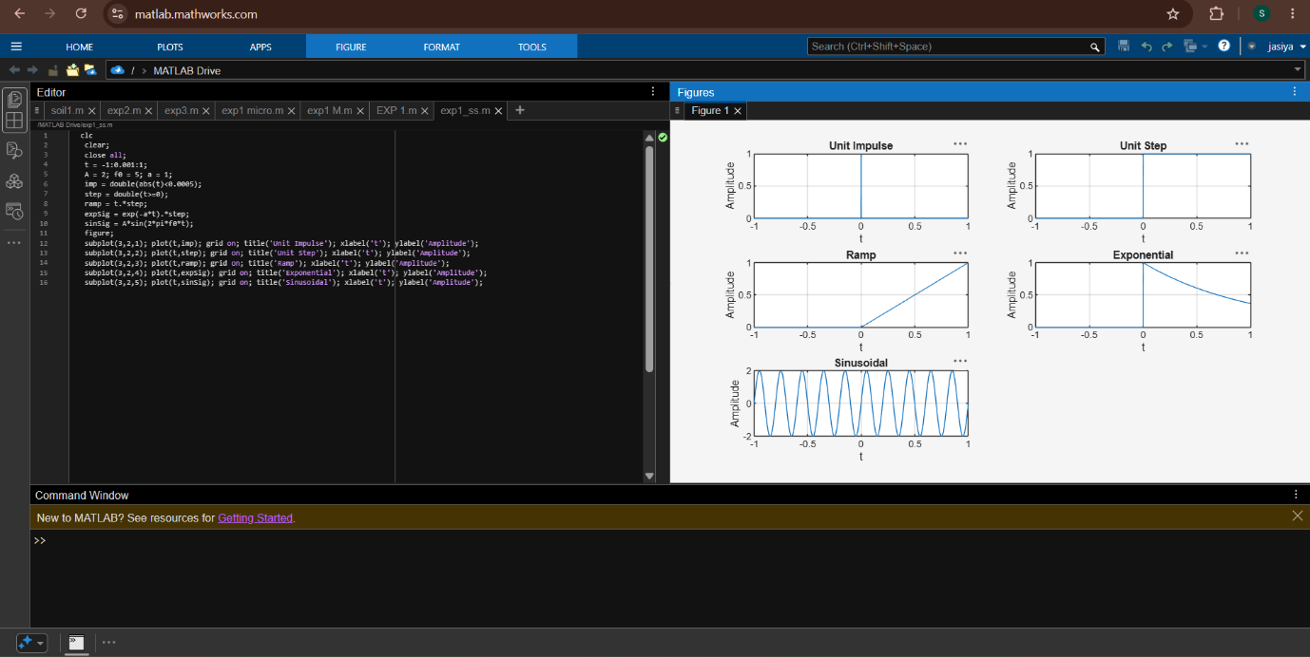
(ii)To generate and visualize basic discrete-time signals and analyze their amplitude and time-index characteristics.
